**Reinforcement Learning Algorithms for Multiple Games**

##### A PROJECT REPORT

Submitted by

**Viral H. Jani (170320107031)**

**Fahim D. Sanghariyat (170320107089)**

**Shaival P. Shah (170320107555)**

***In partial fulfillment for the award of degree***

***of Bachelor of Engineering in Computer Engineering***



##### COMPUTER ENGINEERING DEPARTMENT

##### L. J. INSTITUTE OF ENGINEERING AND TECHNOLOGY

**GUJARAT TECHNOLOGICAL UNIVERSITY**

**AHMEDABAD**

**YEAR 2020-21**

**L. J. INSTITUTE OF ENGINEERING AND TECHNOLOGY**

#### COMPUTER ENGINEERING DEPARTMENT

**YEAR 2020-21**



CERTIFICATE

###### This is to certify that the Project entitled **“Reinforcement Learning Algorithms for Multiple Games”** submitted by **Viral H. Jani (170320107031)**, **Fahim D. Sanghariyat (170320107089), Shaival P. Shah(170320107555)** towards the partial fulfillment of the requirements for the degree of Bachelor of Engineering in Information Technology of L.J. Institute of Engineering and Technology, Ahmedabad, under the Gujarat Technological University, Ahmedabad is the record of work carried out by him under my supervision and guidance. In my opinion, the submitted work has reached a level required for being accepted for examination. The results embodied in this project, to the best of my knowledge, haven’t been sub- mitted to any other university or institution for award of any degree or diploma.

Miss Alpa Rupala Prof. Shweta Yagnik (Assistant Professor, L.J.) (HOD -CE)

**Table of Content**

1. **Certificate II**
2. **Table of Content III**
   1. **Introduction 1**
   2. **Content 2**

##### Key Partners 2

##### Key Activities 2

##### Key Resources 3

##### Value Propositions 3

##### Customer Relationships 4

##### Channels 4

##### Customer Segments 4

##### Cost Structure 5

##### Revenue Streams 5

**Chapter 1.**

**Introduction**

Our project is a game playing bot which plays a range of games against both humans and computers using Deep Q-learning. This project demonstrates that a convolutional neural network can overcome challenges to learn successful control policies from raw video data in complex Reinforcement Learning environments.

We use available research in training and testing deep neural networks to develop a Reinforcement Learning Algorithm that can learn directly from raw image data stored in sequential memory. We can make a web application in which we use reinforcement learning for playing multiple games with user interactions available and it can also perform well on emulators like Atari 2600, which uses the same algorithm

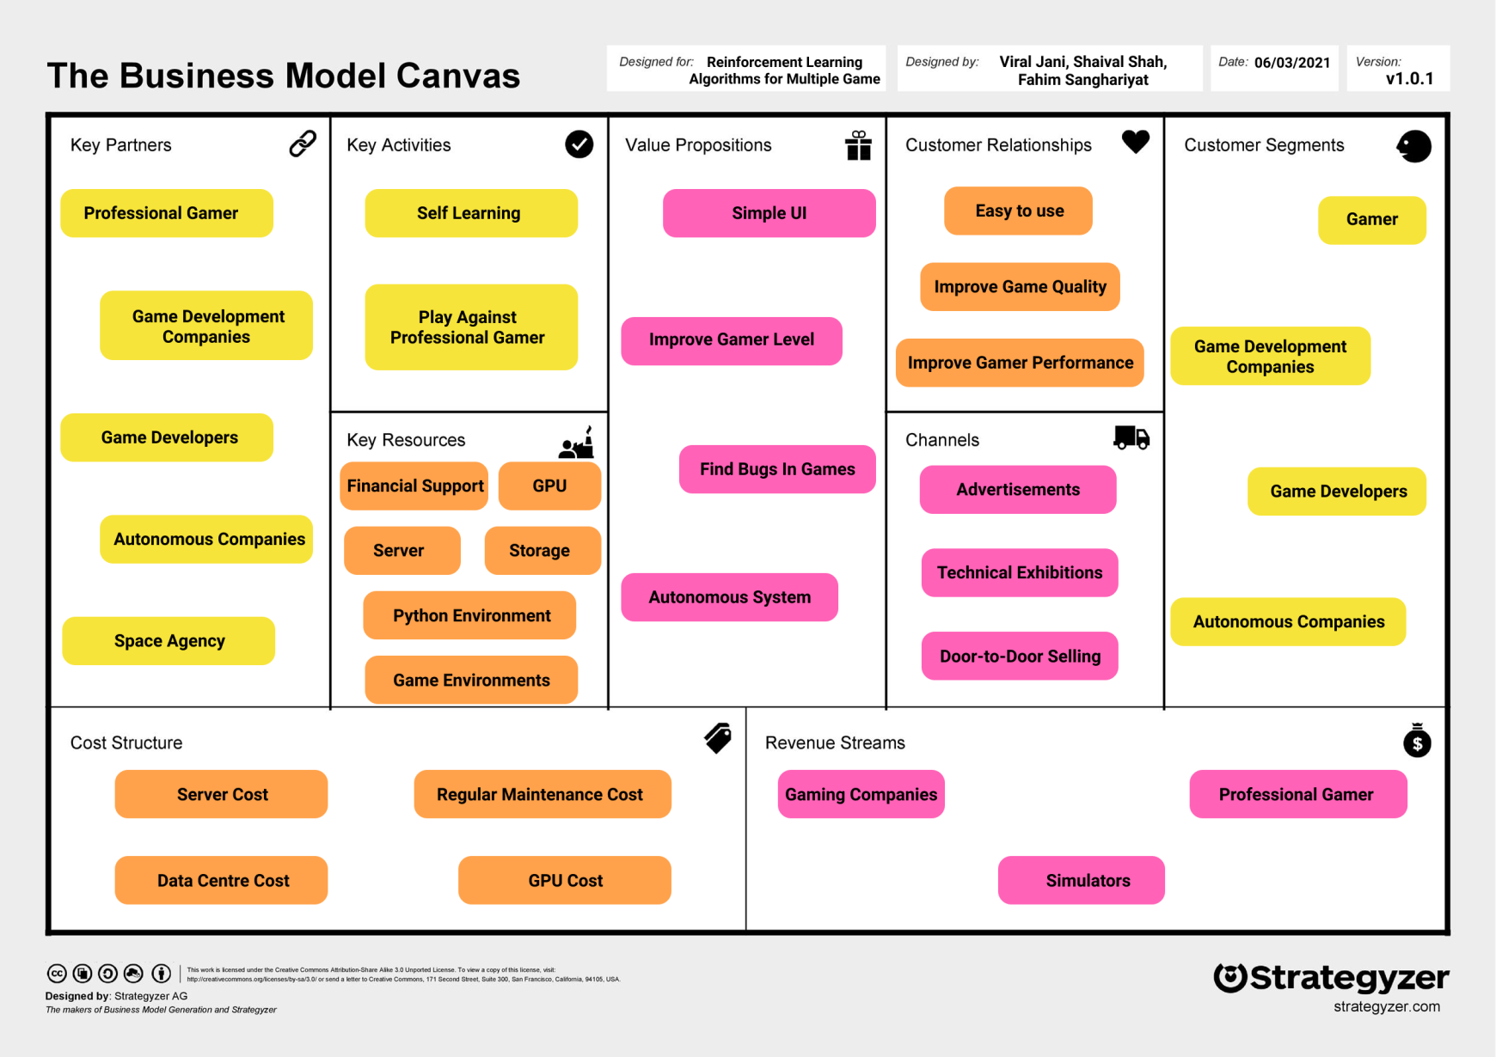

#### Chapter 2

#### Content

## Key Partners

##### Here we talk about partners who can we partner with and know the potential market and activities that they are performing.

* **Professional Gamers**:
  + - * + Professional Gamers play many games in which they play against such bots to improve their performance.
* **Game Development Companies**
  + - * + Game Development Companies can use our product to explore their games more and find new bugs and possibilities.
* **Game Developers**
  + - * + Our product can be highly useful for independent game developers who can use our product for finding mistakes/bugs in their games at a nominal cost.
* **Autonomous Companies**
  + - * + Companies using autonomous devices like self-driving cars, autonomous robots,etc can use our product.
* **Space Agency**
  + - * + Space Agencies can use such algorithms for their programs like space-body landers, navigating vehicles in space, etc.

## Key Activities

##### Here we discuss how we will represent the product to customers. Following can be used for marketing of products.

##### Self Learning

##### The algorithm is utilized so that the agent learns the situation of the game environment and learns the game itself. Slowly, it improves its game play and starts playing better.

##### Playing Against Professional Gamers

##### Many professional game players can use this algorithm and play against it to improve their own performance and score better in championships/tournaments.

## Key Resources

##### Here we talk about what resources are needed for the development of the product.

##### GPU

##### We need GPUs with high processing power for the system to effectively learn games and improve its performance.

##### Server:

* + - * + An array of server systems will be a key requirement for storing data.

##### Storage

##### Some storage is required to store the data of the game as the agent starts playing and learning it.

##### Python Environment

##### There must be a Python Environment installed in the host for running the algorithm.

##### Game Environment

* + - * + A game is required for development and programming of the system.

## Value Propositions

##### Here we directly come in contact with the customer. We will spread awareness about the product by telling people how useful it is to them and what support we provide.

* + **Simple UI**
    - * + Customers can easily cruise through the portal using our scrupulous UI*.*

##### Improve Gamer Level

##### Game players can vastly improve their game scores/levels and learn new strategies by playing against our algorithm’s agent.

##### Find Bugs in Games

##### If some game developing companies , especially those which have world building in their games, want to improve their player experience and find bugs, our agent’s quick and wide exploration of game can be highly useful in it.

##### Autonomous Systems

##### In autonomous systems like self driving cars, such algorithm can be used to find out new and efficient ways and avoid accidents.

## Customer Relationship

**In this section it is given that how relationship with customer will be managed by our services**

##### Easy to Use

Customers can easily cruise through the portal using our UI.

##### Improve Game Quality

Customer’s game quality improves greatly.

##### Improve Player Performance

The performance of a player playing against an agent using this algorithm improves.

## Channels

##### In this section it is given how we will reach the customer. The marketing mediums we are using to promote the product.

* + **Advertisements**
    - * + Cheapest and fastest means to reach large number of people, social media. Electronic medium of reaching people.

##### Door-to-Door Selling

* + - * + Going to institutes individually, pitching the product and then, advertise it.
  + **Technical Exhibitions**
    - * + Going to technical meet-ups and exhibitions to promote the product**.**

## Customer Segments

##### Here we discuss about customers whom we are targeting to sell the product.

* **Professional Gamers**
  + - * + Gamers play many games in which they play against such bots to improve their performance.
* **Game Development Companies**
  + - * + Development Companies can use our product to explore their games more and find new bugs and possibilities
* **Game Developers**
  + - * + Product can be highly useful for independent game developers who can use our product for finding mistakes/bugs in their games at a nominal cost.
* **Autonomous Companies**
  + - * + Companies using autonomous devices like self-driving cars, autonomous robots, etc can use our product.

## Cost Structure

##### Here we discuss the cost that has been inherited in business modal. Before that first some assumption needs to be made. According to COCOMO modal it takes approx. 8 months to complete the project. All the calculations are done approximately

* + **Administration**
    - * + Admin cost is the one which is related to overall administration.

##### Data Centre Cost

* + - * + Data centre cost consists of renting server racks, server space, cables etc.

##### Broadband Cost

* + - * + Electricity bill of the office will be around Rs. 500/month. So, for 8 months it will be Rs. 4,000. Wi-Fi plan will be Rs. 5,000 for 12 months for 6 Mbps speed.

##### Regular Maintenance Cost

* + - * + Regular maintenance cost is the one which represents the complete maintenance of the system periodically.
* **GPU Cost**
  + - * + Such Reinforcement Learning algorithms require high processing powers due to which expensive GPUs need to be purchased**.**

## Revenue Streams

##### Here we discuss the main source of income from the system

##### Gaming Companies

##### Gaming companies offer suffer huge losses due to bugs in their games. Therefore, they may use our product to avoid losses and improve their games.

##### Simulators

##### Products using simulations like self driving cars, space landers, etc may use our product to improve their efficiency and performance.

##### Professional Gamers

##### Professional gaming is a highly competitive sport. To gain edge over their peers, gamers may buy directly from us to improve their performance in certain games.